## Appendix 6 – Sample Runs of the Yarnatron Yarn Search and Sort App

Unzip the Yarnatron.zip folder and double-click on yarnatron.exe. (NOTE: The app was turned into an executable with py2exe, which doesn’t compile and does include every dependency, whether used or not, so the file size is large.) In the background, Yarnatron.exe reads a local csv file, packaged with the app.

### Sample Run #1: Sort by Pilliness Score

Below is the initial start screen for the Yarnatron. Hit the ‘I’m ready’ button to begin.

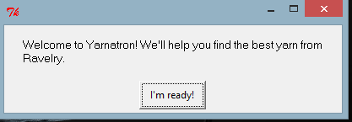

You can choose a Single Fiber or Blend or No Preference – We start with ‘No preference’ as the first example.

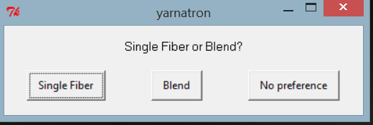

Next screen will give you a choice of fibers, try ‘Select All’ to widen your options and then hit ‘OK’ button to continue. 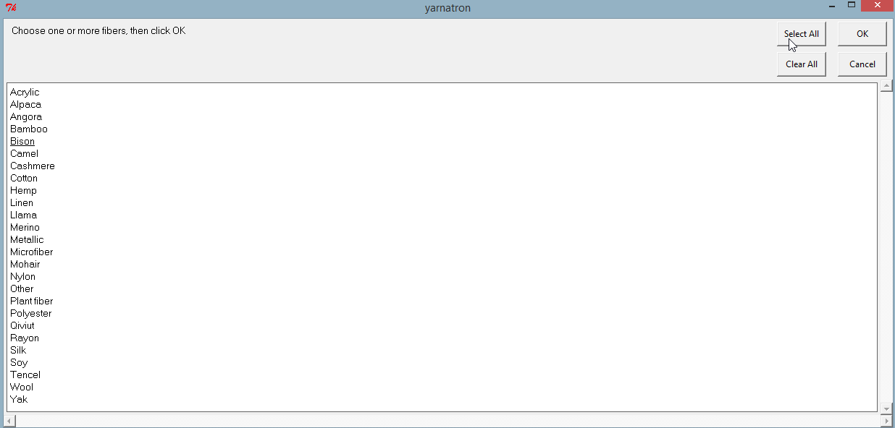

Now you can choose Machine Washable yarn or not. ‘No Preference’ will offer more choices. We choose ‘No Preference’ initially to open up the yarn selections.



You can now filter by a brand name of a yarn, or choose ‘Cancel’ and not filter by a yarn brand.

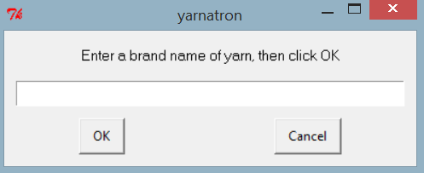

Now you are asked to choose a yarn weight. We try ‘Worsted’ as a first filter. You can also choose multiple weights by clicking on each weight desired, or use ‘Select All’. Once you have made your choice(s), hit the ‘OK’ button to continue.

(Hitting ‘Cancel’ on any of these screens is equivalent to making no selection, which will also technically select all…)

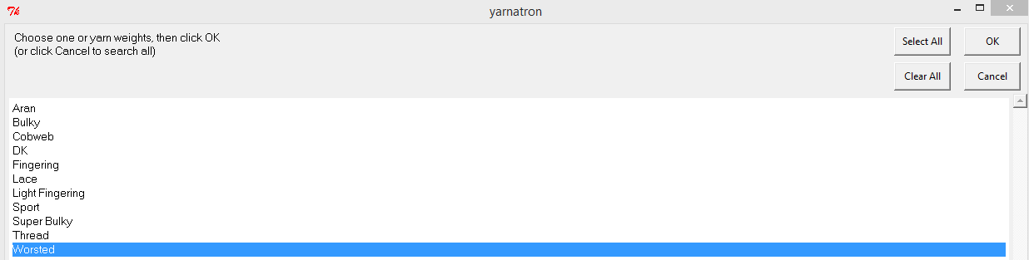

The final choice is whether the yarn is ‘Less Pilly’ or ‘Less Splitty’. These are the two main yarn attributes our project classifier performed supervised learning on with the Rocchio Method using Cosine Similarity.

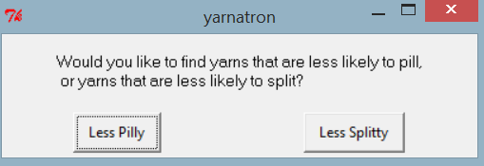

We go with ‘Less Pilly’ in this first example.

You will then get a summary screen showing all your choices made, before the Yarnatron program will return your search results.

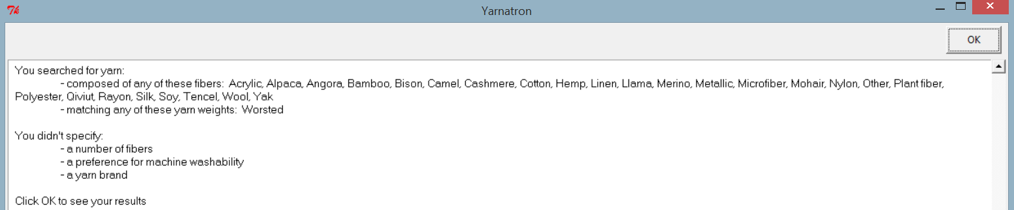

Below is an example of the search results returned. The results are sorted by least likely to bill, to most likely to pill.

You can see that, while we did not put any filters on the yarn content, most of these yarns are blends and none of them contain wool. This is in line with our domain knowledge about what makes a yarn less likely to pill.

The URL for each yarn page is displayed at right. The user is reminded that they’ll need to be a member of Ravelry.com to visit these pages.

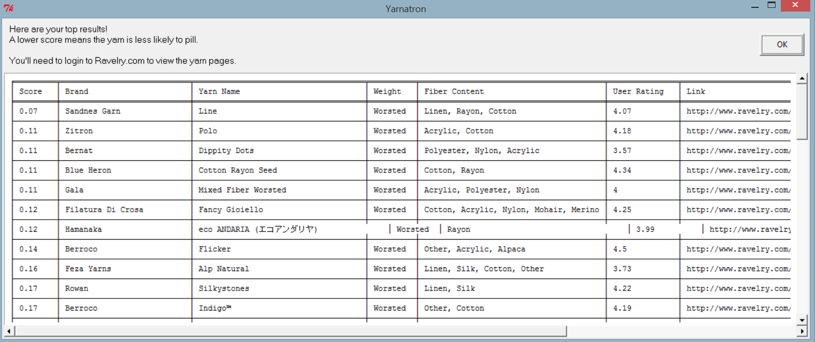

Once you are done examining the search results, hit the ‘OK’ button and you may continue to search for more yarn or exit as the screen below shows as options.



### Sample Run #2: Sort by Splittiness Score

This time we will choose ‘Single Fiber’ in the first screen and select multiple fibers as seen below.

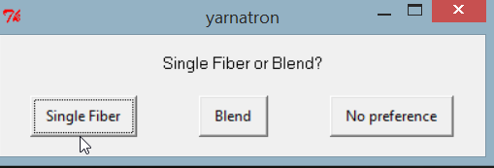

Once your chosen fibers are ready, hit the ‘OK’ button. Even though we choose a Single Fiber, we can still pick multiple fibers that we would be interested in. In other words, on this search we say we would be interested in 100% cashmere or 100% cotton, but not 100% alpaca, and not any blend of fibers.

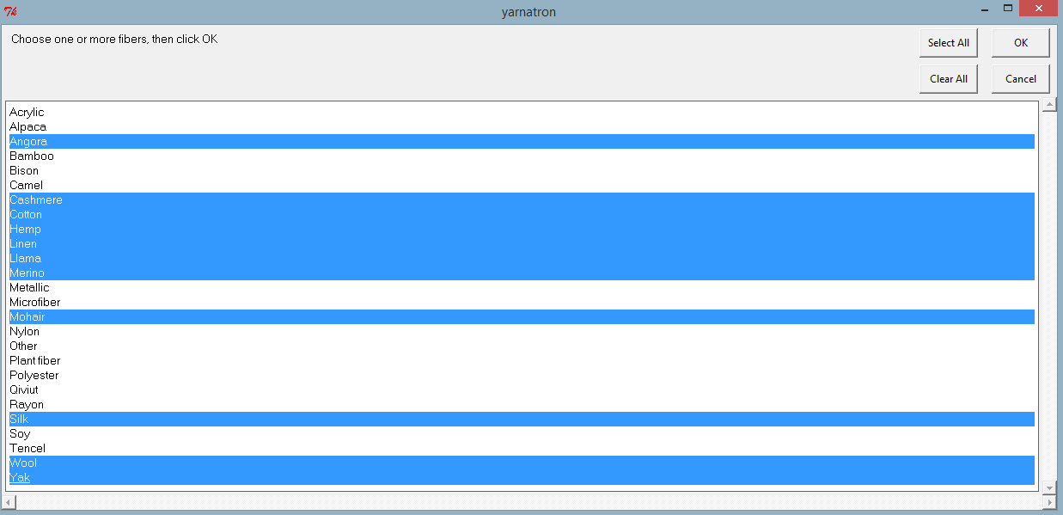

Now you can choose Machine Washable yarn or not. ‘No Preference’ will offer more choices. We choose ‘No Preference’ initially to open up the yarn selections.



You can now optionally filter by a brand name of a yarn.



Now we can choose yarn weights but we will use ‘Select All’ to have more choices.

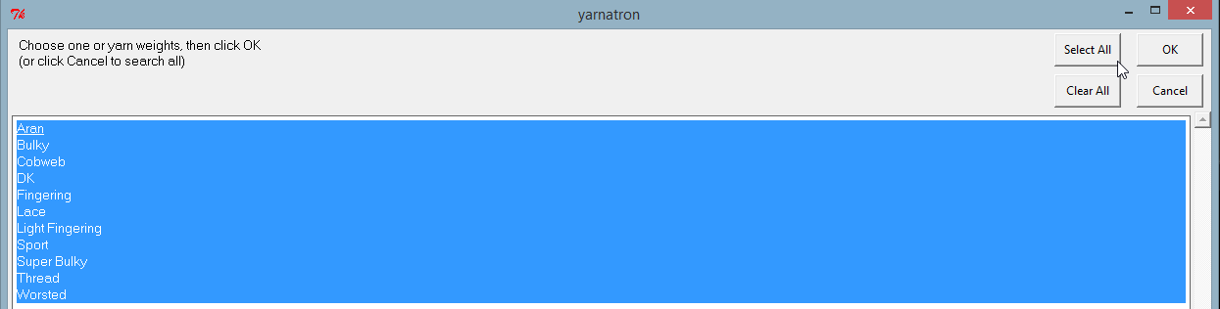

The final choice is whether the yarn is ‘Less Pilly’ or ‘Less Splitty’. These are the two main yarn attributes our project classifier performed supervised learning on with the Rocchio Method using Cosine Similarity.

We go with ‘Less Splitty’ in this first example.

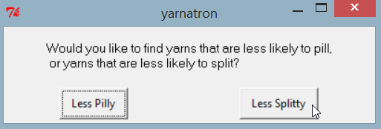

Then we get a summary of all our choices made so far.

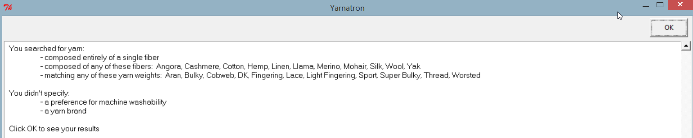

Hit the ‘OK’ button to see the yarn chosen from the result search.

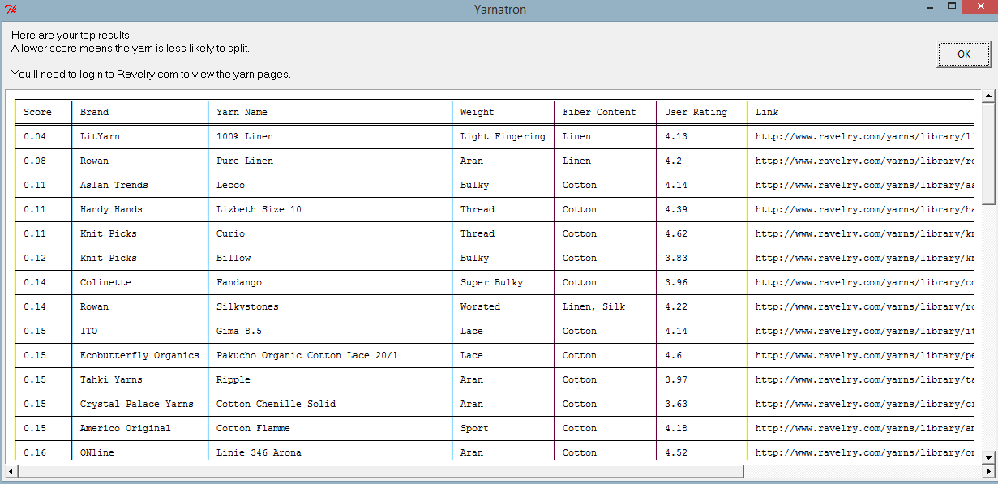

Hit ‘OK’ once you have examined the yarn list selected based on your last set of choices.

You may continue to search for more yarn or exit as the screen below shows as options.



### Sample Run #3: Enter search parameters that are too narrow

This time we will enter search parameters that we know are too narrow to return results: Bulky weight, Machine-washable 100% Qiviut! (Qiviut is made from “the delicate underwool of the Arctic muskox” and costs over $100 per ounce (or approximately 50 cents per yard for a yarn that’s as thin as thread). It is 20 times warmer than wool, light as a feather, and softer than cashmere.)

Below is the initial start screen for the Yarnatron. Hit the ‘I’m ready’ button to begin.



Choose ‘Single Fiber’ in the first screen and select multiple fibers as seen below.



Choose only Qiviut

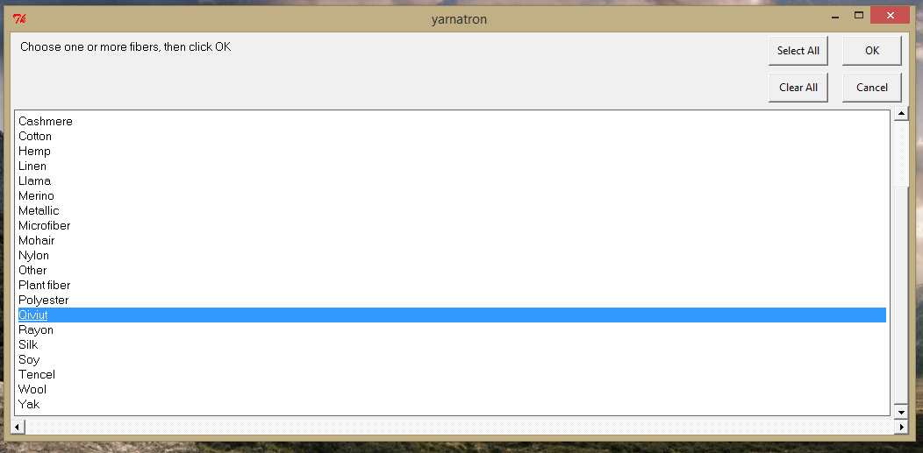

Choose machine washable only



Leave the brand name blank:



Select only Bulky from the yarn weights

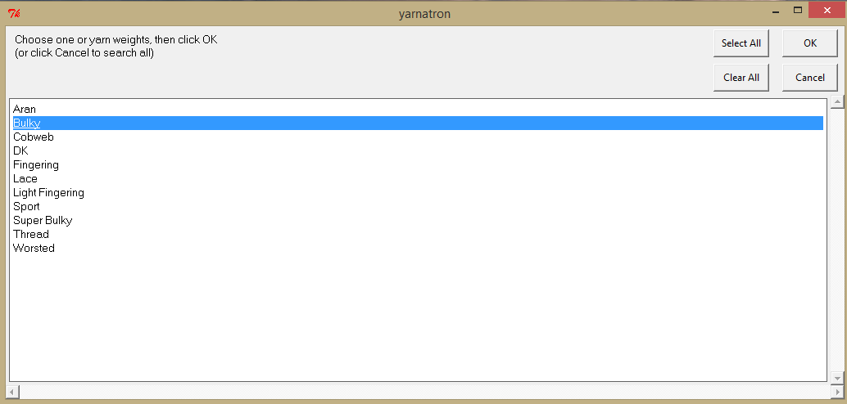

Choose “Less Splitty”



The app returns a message that the search was too narrow. You have an option to try again or to exit.

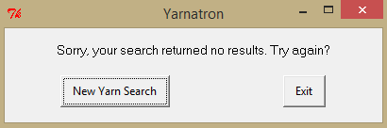

### Sample Run #4: Search by company name

This time, we’ll leave the other filters open so that we can find all yarns by a single company. But you can use the company name filter in combination with any of the other filters, as well.

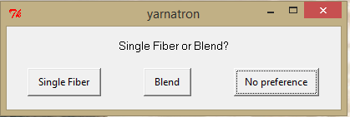

Clicking ‘cancel’ (choosing not to use a filter) has the same affect as ‘select all’.

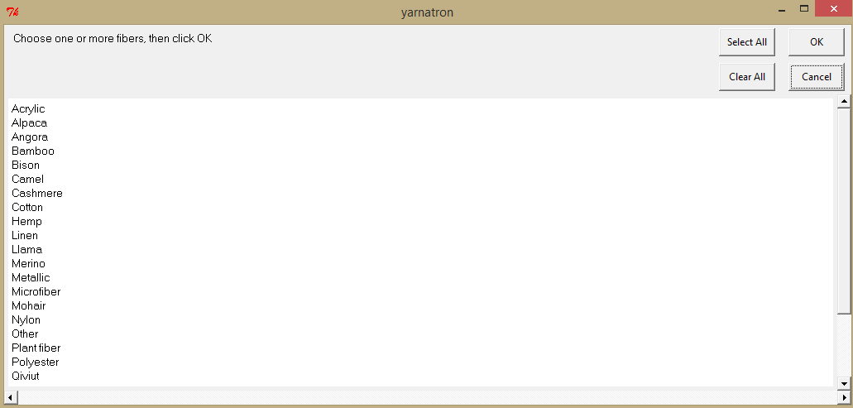

Machine wash? No preference.



Yarn Brand Name Partial Text Search

The program uses a partial, case-insensitive search, so searching ‘malabrigo’ will find the yarn brand “Malabrigo Yarn”.

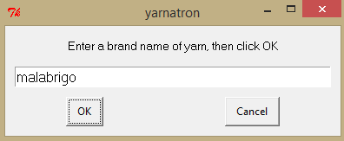

Choose all yarn weights

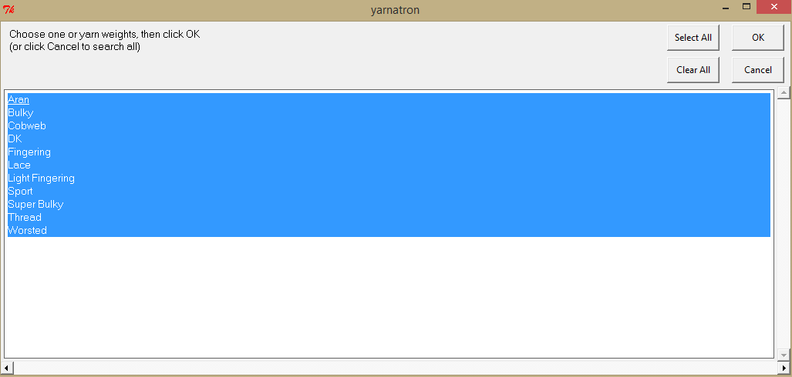

Choose ‘Less pilly’ as our sort method, because brand’s yarns are super soft and thus known to pill:



See a summary of what we searched for:

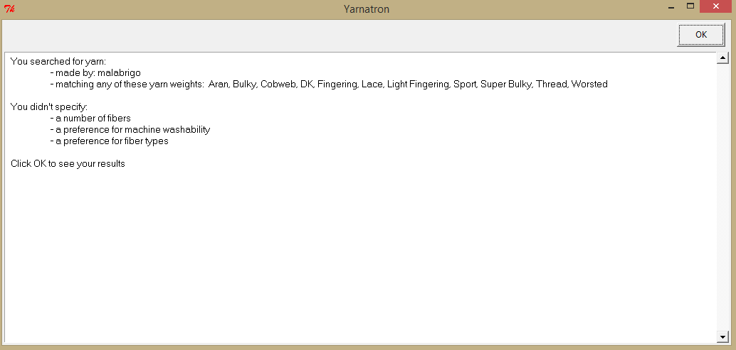

View results for all yarns made by Malabrigo:

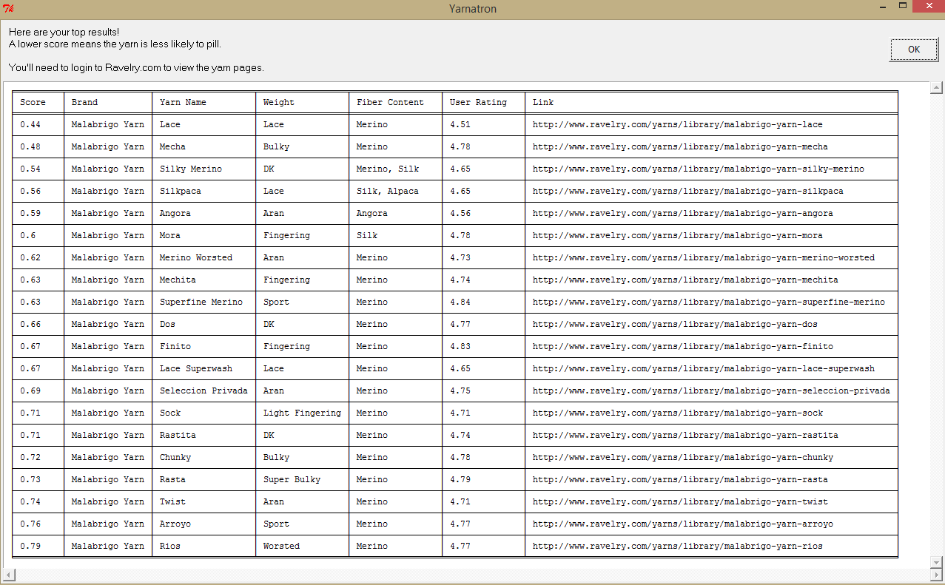

We can see that none of these yarns have a pilly score on the low-low end, but that the yarns that are a blend of silk with something else are on the lower range than yarns that are 100% merino; the two yarns that are 100% merino but rated less likely to be pilly are known to be exceptions to the company’s reputation.